Ravan Muradzada
Contents
Question 1 1
Question 2 2
Question 3 3
Question 4 4
Question 5 6
Question 6 7

Question 1
Let’s create a file and check it
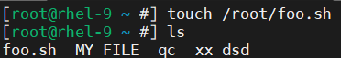
Then we give execute permission to this file:
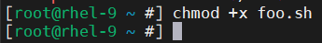
In the script file:
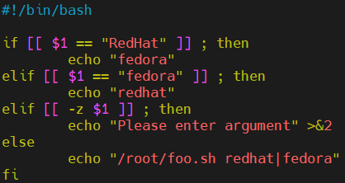
BTW, here ‘>&2’ means redirecting the result to stderr.
When we check the result:
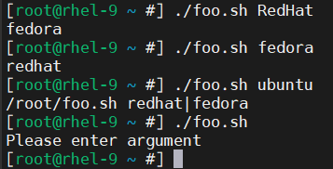

Question 2
Let’s create a file and give execute permission to it:
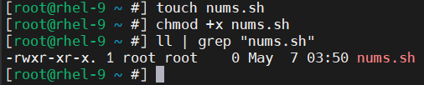
The script file:
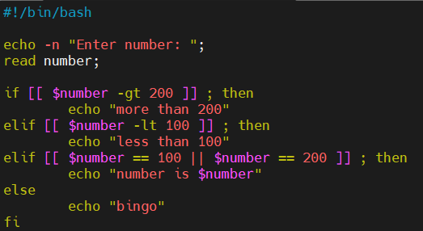
BTW, there is no condition about if the number is equal to 100 or 200, so I have added it myself for fun.
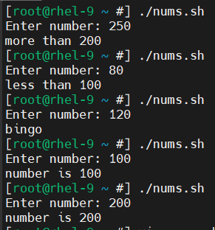

Question 3
Let’s create a file and give an execute permission to it:
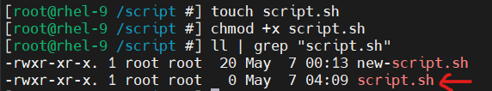
Script file:
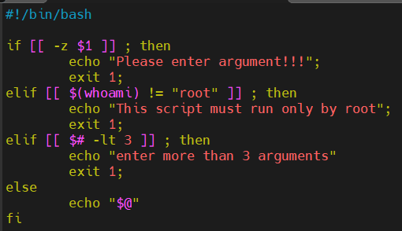
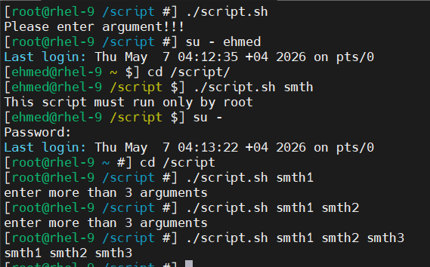

Question 4
Let’s create the files:
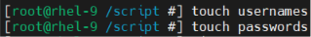
Then fill them.
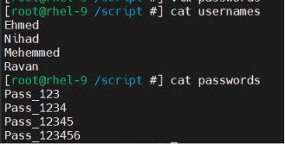
Then create the script file:
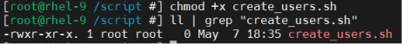
The script:
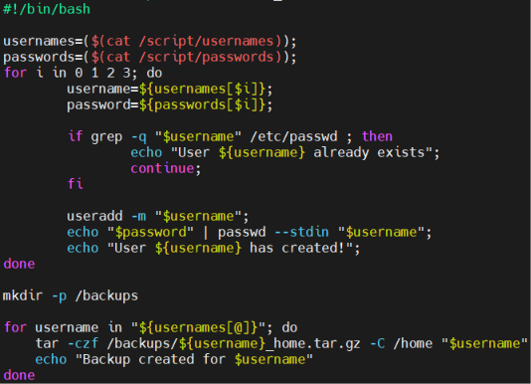
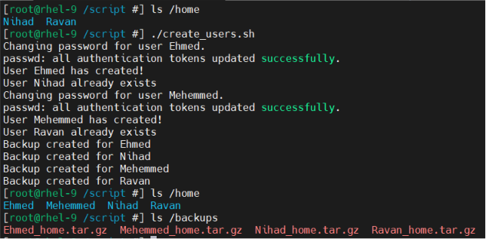

Question 5
Let’s download the package to send mail:
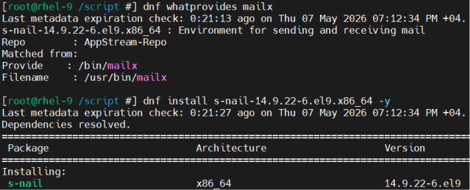
Let’s create the file:
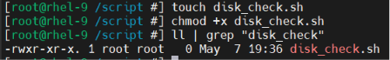
The script:
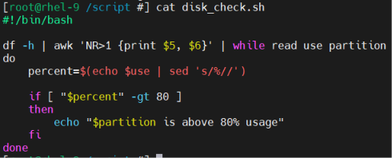
- Here, `df -h` helps us to see disk spaces. `awk` command helps us to select specific one or more columns. I have selected the fifth and sixth columns which are “Use” “Monted On”. Here, `NR>1` means to ignore the first line (header part).
- We give “use” name to fifth column and “partition” name to sixth column.
- `sed` command is used to replace the part of the string. Here, from “Use” column we remove “%” (replace it with nothing). So, if it is 90%, it is converted to 90.
- `-gt` means “greater than”.
If we run the command:
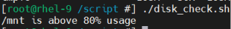
If we really check it with running `df -h`:
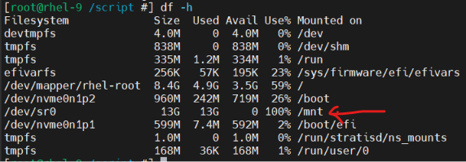

Question 6
I have created a script file:
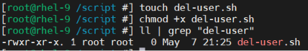
In that script, we can easily convert `if-elif-else` logic to `case` system:
